
Welcome to our July Newsletter. We hope you enjoy looking back at all the wonderful activities and memories we've shared at the homes over the past few months.
I would also like to introduce myself, my name is Kelly Jordan, I joined the company as the Peripatetic Manager however I am pleased to share that I have been offered the role as the Registered Manager at Ivy Lodge and accepted. I look forward to working with the team and ensuring the people we support live a fulfilling life. Thank you for the warm welcome and I am looking forward to my future with the company.

Inside the Ivy’s - July 2026
The Newsletter of Ivy Care

“Talented” “Inspiring”
“Skilled” “Creative”

I am very impressed with the great work that has been undertaken to ensure the people we support have the best time possible.
Thank you for all the great work you do and please keep it up!

In this Issue
Welcome Page | Page 1
Learning Disability Week | Page 2
Celebrating Pride Month | Page 3
Family Day | Page 4
Employee congratulations | Page 5
Employee Service Awards | Page 6
2026 Awareness Days | Page 7
Keeping Busy At Ivy Lodge | Page 8
It’s a Bake off at Ivy Mead | Page 9
Professional Visits | Page 10

Richard Slingsby – Executive Chairman

Learning Disability Week

Ivy Dene celebrated Learning Disability Week with a fantastic week of fun, laughter, and togetherness. Everyone enjoyed a talent show, superhero-themed activities, delicious food, and plenty of opportunities to come together with friends from across the Ivy services.
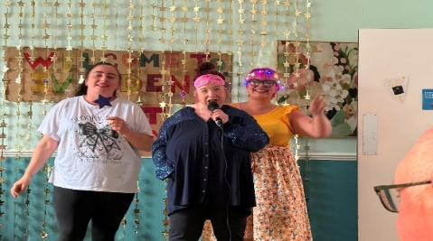
Ivy Dene had a great time at celebrating learning disability week with a talent show and superhero theme. Lucy enjoyed getting up with her staff to blast out a song or two!

Jonathan took part in the talent show, entertaining everyone with a selection of songs and showcasing his fantastic guitar skills. It was wonderful to see Jonathan getting involved, enjoying himself, and confidently taking part in the celebrations.
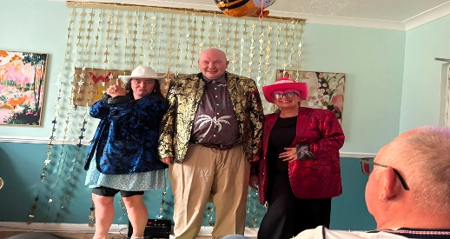
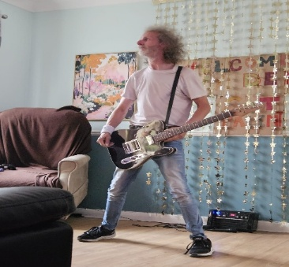
Lee had a fantastic time taking part in the talent show, singing some of his favourite songs alongside the staff. It was wonderful to see him joining in, having fun, and enjoying the celebrations with everyone.

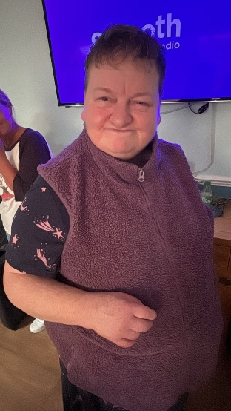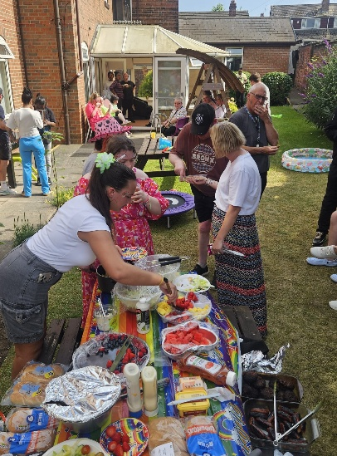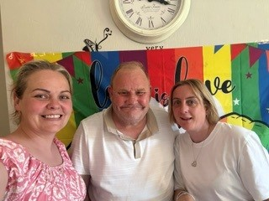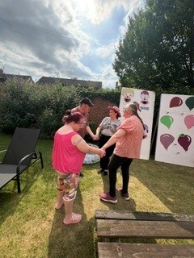

Celebrating Pride Month

Throughout Pride Month, Ivy Care has proudly celebrated diversity, inclusion, and the importance of being yourself.
To mark the occasion, the Ivy services came together for a fantastic Pride celebration at Ivy Cottage. The people we support, and our teams enjoyed a day filled with music, colourful decorations, fun activities, laughter, and enjoyed painting their own t-shirt. It was a wonderful opportunity for everyone to come together, celebrate individuality, and show support for one another.

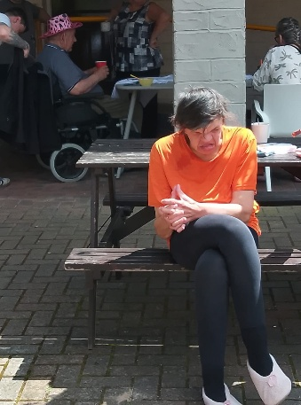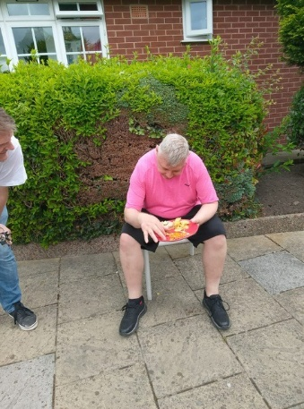

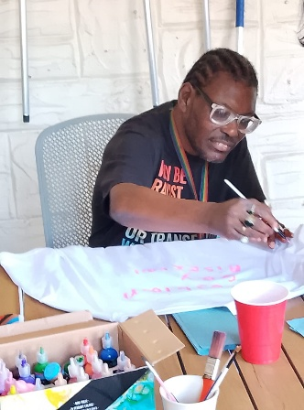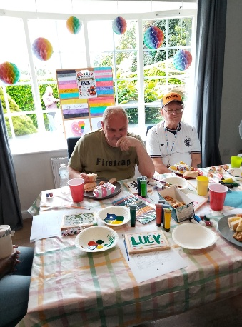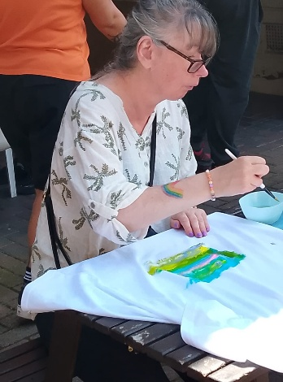

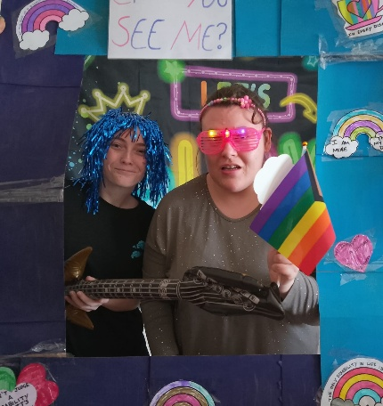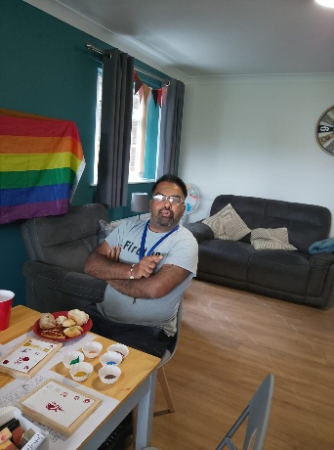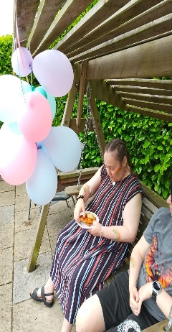
Family day at Ivy Stone Lodge

Stone Lodge had a fantastic time celebrating Learning Disability Week by bringing everyone together for a family day filled with fun and laughter. It was a wonderful opportunity for the people we support, their families and staff to come together, make memories and celebrate everything that makes each person unique.

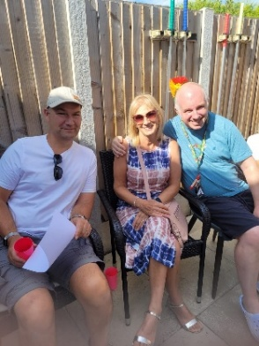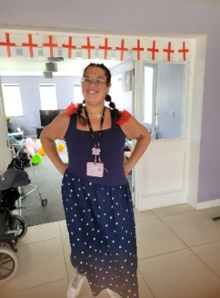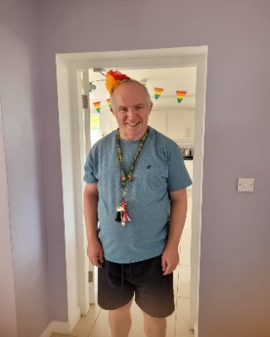

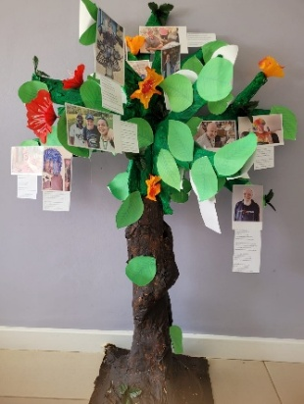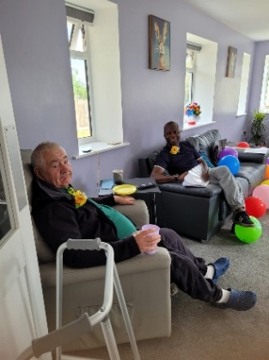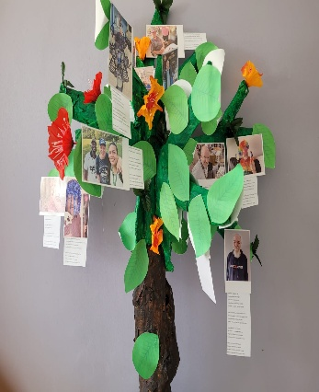

As part of the celebrations, we created a "Do You See Me?" Tree, where everyone shared positive words, talents, interests and the things that make them who they are. The tree became a colourful reminder that every person has their own strengths, personality and story, and that people should be seen for who they are, not just their disability.

Employee Congratulations

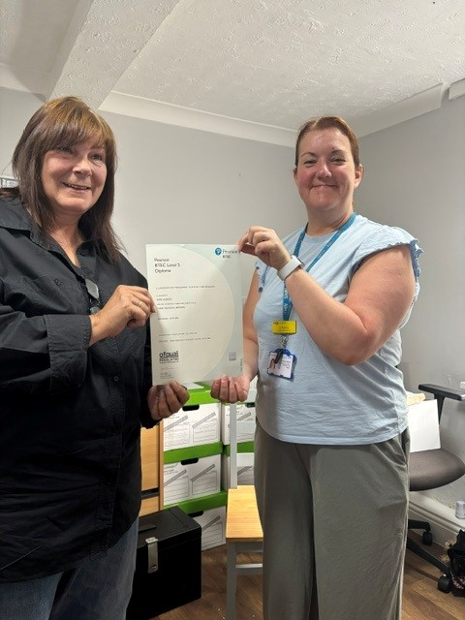
Congratulations to Ann Garside on achieving her Level 5 Leadership and Management NVQ!
Your hard work, determination, and dedication have truly paid off. This is a fantastic achievement, and we are incredibly proud to have you as part of the Ivy Care team.
Thank you for everything you do, Ann, and congratulations once again on this well-deserved success!

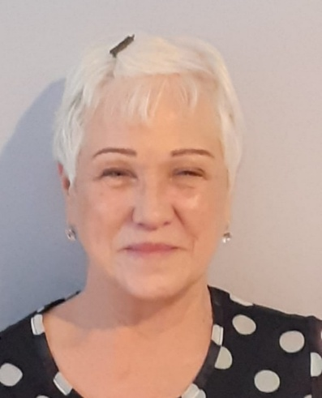
Congratulations to Jackie Hutchinson on her appointment as Manager of Ivy Stone Lodge!
Jackie has now taken on the role of Service Manager and is preparing for her Fit Person Interview as part of becoming the Registered Manager. This is an exciting step, and we wish Jackie every success in her new role.

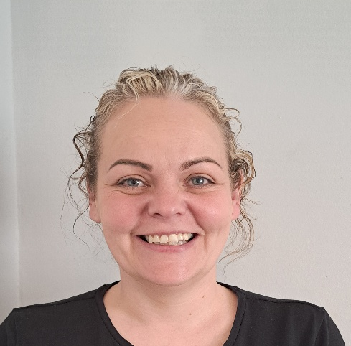
Congratulations, Steph Turton, on becoming the Assistant Manager at Ivy Dene! This is a fantastic achievement and thoroughly deserved.
Wishing you every success in your new role. I'm sure you'll do an amazing job, and I hope this is the start of many more exciting opportunities. Best of luck—you've got this!


Employee service awards

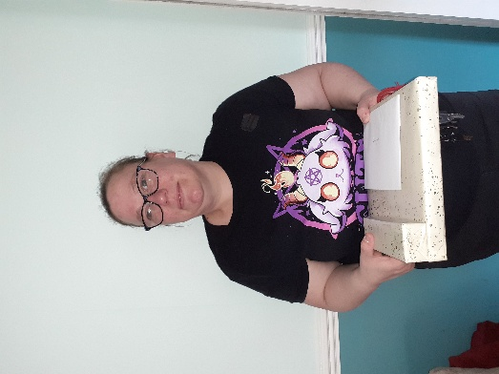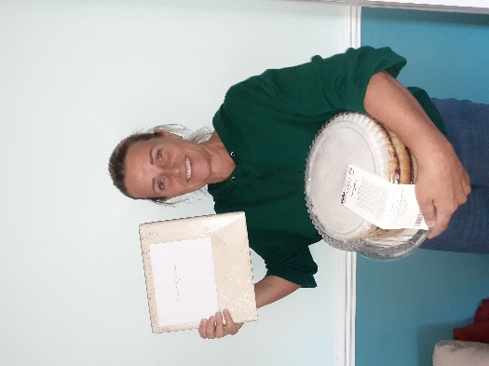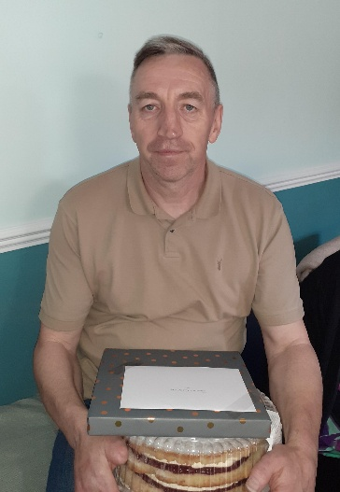
Janet Rhodes, from Ivy Deborah Staniforth, from John Clark, From Ivy
Dene. Dene. Dene.
Senior Support worker Support Worker. 15 Years! Support Worker. 10 Years!
5 years! Congratulations. Congratulations! Congratulations!

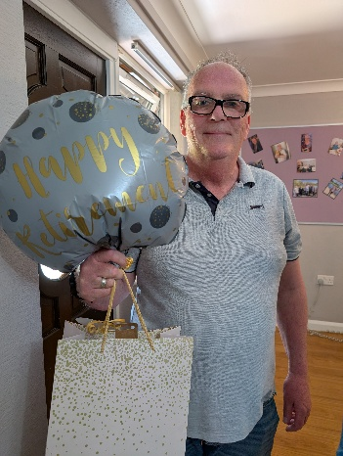

Congratulations and good luck to Andy Galvin. Andy joined Ivy Care in June 2004, initially working as a peripatetic Senior Support worker and then moving across to Ivy Mead and Ivy Court as a full time senior. In recent years Andy stepped down to our pool support until making the decision to retire.
We wish you good luck in your new adventure Andy, thank you for your years of dedication and commitment. This is truly appreciated.


2026 Awareness Days

Halfway through the year but still so much to celebrate and do!! | July  24th – Samaritans awareness day  25th – National Schizophrenic awareness day | August  7th August – National Purple Heart Day | September  23rd – International Day of Sign languages  14th – 20th – National inclusion week | October  (ADHD Awareness month)  8th – World sight day  10th – World mental health day  18th – World Menopause Day
November  14th Nov – 20th Dec – UK disability History month | December  3rd – International Day of Persons with disabilities | 

Keeping Busy at Ivy Lodge

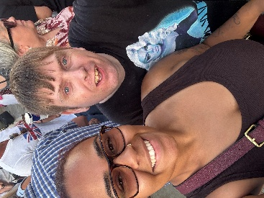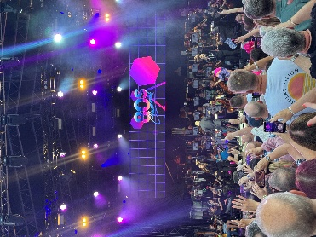
Damien has a great time with his staff at Banana Rama. This was the first time for Damien at an outdoor concert and he loved it. Plenty more will be getting booked.

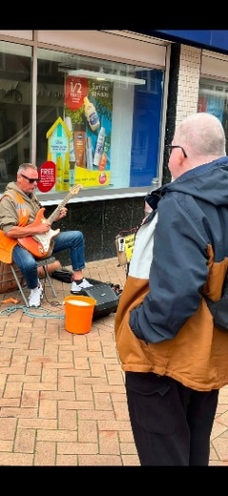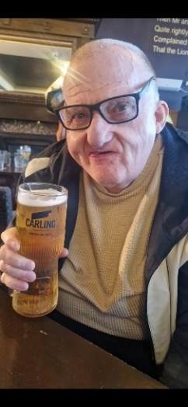
Neil had a great time on his holiday to Blackpool. Five days enjoying a few drinks, visiting the zoo and listening to the buskers in the street and visited Blackpool tower.

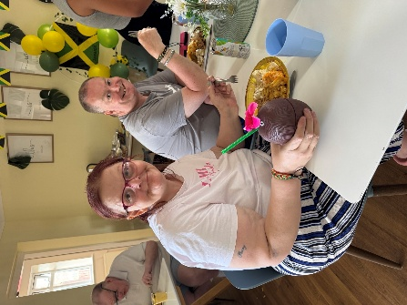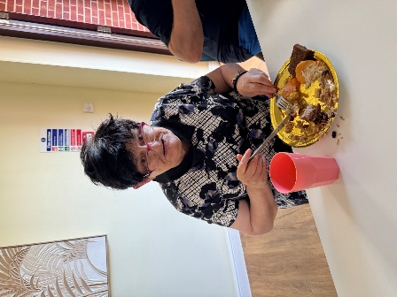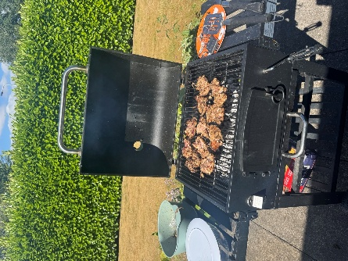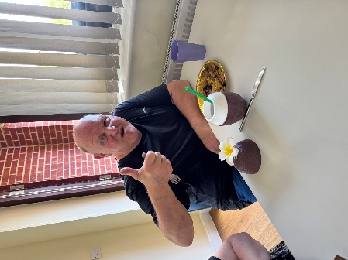
Everyone had a fantastic time at our Mexican Night at Ivy Lodge! 🌮🎉
It was wonderful to see everyone enjoying a variety of delicious new flavours, with our famous jerk chicken stealing the show as the favourite of the evening! 🍗🌶️
The beautifully home-decorated dining area created the perfect atmosphere, making the night feel extra special. From the colourful decorations to the tasty food and great company, it was an evening full of smiles, laughter, and happy memories.
It’s a Bake Off at Ivy Mead
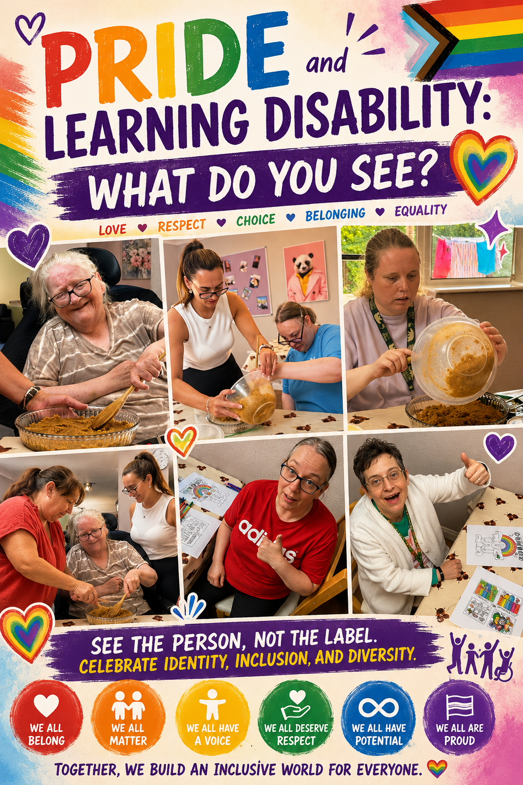


Professional Visits

Promoting Health and Wellbeing at Ivy Dene
The team at Ivy Dene recently welcomed Wakefield Adult Community Learning Disability Health Team in June.
The visit to the service was to talk about the importance of looking after our health. Staff spoke with both the people we support and staff about checking for lumps and bumps, the importance of regular health checks, and recognising any changes that should be discussed with a healthcare professional.
The session was delivered in a person-centred way, with information adapted to meet the individual needs of the people we support. This helped everyone to understand the information in a way that was meaningful and accessible to them.
The visit also highlighted the importance of attending regular health reviews and exploring reasonable adjustments to ensure everyone can access healthcare in a way that meets their needs.
Everyone enjoyed Debbie's friendly and engaging approach. The people we support, and staff took part really well, asking questions and joining in with the discussions. It was a valuable session that helped build confidence and encouraged positive conversations about staying healthy.

And to end with a thank you!

